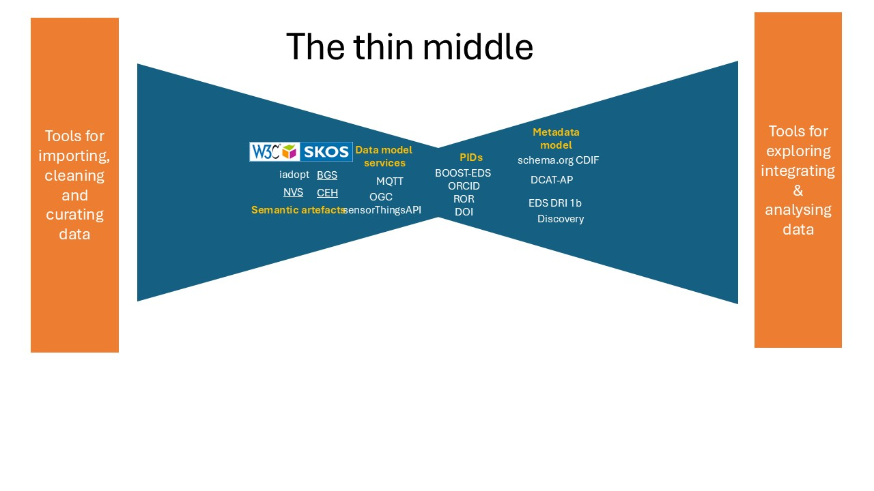
The "thin or narrow middle" is defined as using the minimal set of services essential for the system's core, with only these services being standardised. For EDS Commons we provide specifications for persistent identifiers (PIDs), a data model, and a metadata system all underpinned by semantic artefacts and their accompanying tools.
PIDs
PIDs can identify many different entities. These can be born digital (e.g. documents,
data, software, services - otherwise known as digital objects - and collections made of
them), physical (e.g. people, instruments, artefacts, samples), or conceptual (e.g.
organisations, projects, vocabularies).[1]
The PIDs we are focusing, include identifiers for entities that are core to the EDS data commons and are listed below[2]. We chose those as DOIs are already used by all EDS data centres, ORCIs and RORs are widely accepted and BOOST- Instrument PIDs because this is the service developed for instrument identifiers by the BOOST project.

Short Name | LongName | Official Page | Maturity | Globally resolvable | Object Type
ORCID | Open Researcher and Contributor ID | https://orcide.org/ | Emerging | Yes | People
ROR | Research Organisation Registry | https://ror.org/ | Emerging | Yes | Organisation
BOOST-Instrument PIDs | Identifier for Instruments |  | Emerging | Yes | Instruments
DOI | Digital Object Identifier | https://www.doi.org/ | Mature | Yes | Publication
NVS | NERC Vocabulary Server | https://vocab.nerc.ac.uk | Mature | Yes | Semantic Repository
EnvThes | EnvThes - Thesaurus for long term ecological research, monitoring and experiments | https://vocabs.lter-europe.net/envthes/en/ | Mature | Yes | Semantic Repository

Semantic Artefacts & tools
Controlled Vocabularies
Ontologies
The Semantic Analyser
VocPrez
SKOSMOS
OWL
SKOS

Data Model
For sensor data, we adopted the SensorThingsAPI as the data model,
The OGC SensorThings API provides an open, geospatial-enabled and unified way to interconnect the Internet of Things devices, data, and applications over the web. At a high level the OGC SensorThings API provides two main functionalities and each function is handled by a part. The two parts are the Sensing part and the Tasking part. The Sensing part provides a standard way to manage and retrieve observations and metadata from heterogeneous IoT sensor systems. The Tasking part provides a standard way for parameterizing - also called tasking - of task-able IoT devices, such as sensors or actuators.
We chose the OGC SensorThingsAPI because it provides both an API standard and a data model, it is open enough to enable inclusion of domain specific metadata and controlled vocabularies, works well with MQTT and allows for the publication of data streams
We plan to publish an EDS profile of the sensorThingsAPI to enable practical interoperoperability. This profile will semantically enhance the standard with controlled vocabularies and will specify the common metadata elements to describe a sensor and its lifecycle.
We have not identified the file type as we are only dealing with streams
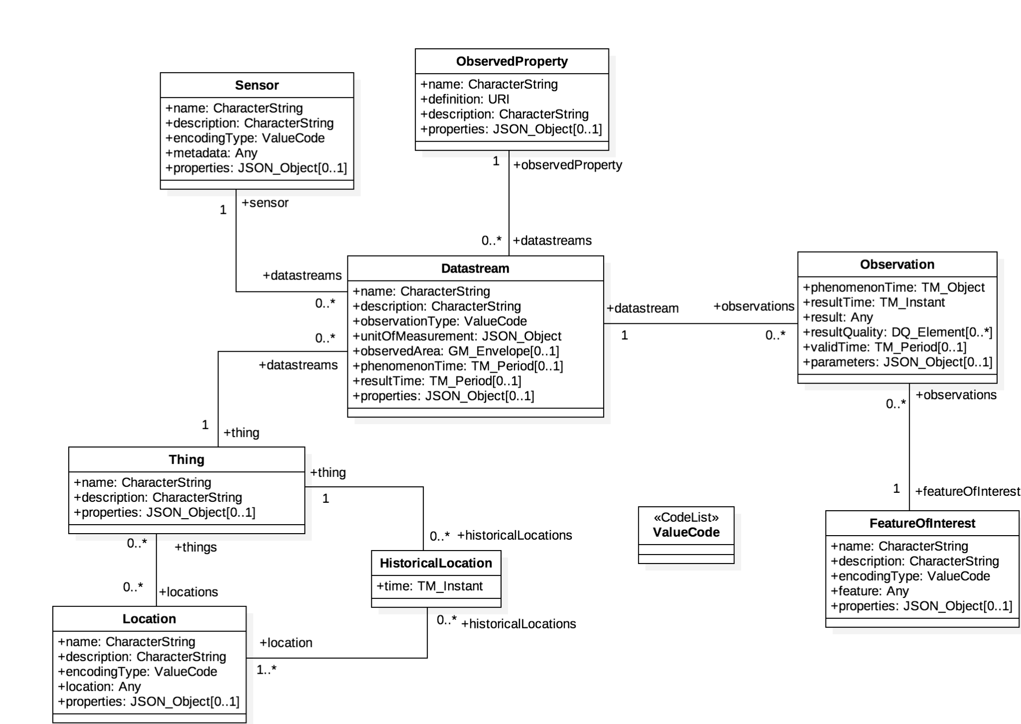

Discovery metadata model
Additionally, we specify a discovery profile applicable to all EDS data, leveraging schema.org, CDIF, and FE-DCAT-AP to ensure alignment with the European Open Science Cloud (EOSC) and Cross Domain Interoperability Framework standards.

file:///C:/Users/alexk/Downloads/a%20persistent%20identifier%20pid%20policy%20for%20the%20european-KI0420576ENN.pdf
https://zenodo.org/records/11396767

